Quiz Show



In this project you will make an AI-powered quiz show, testing a machine learning model on general knowledge questions.

You will use a pre-trained machine learning model that has been trained to find answers to questions in Wikipedia pages.

This project worksheet is licensed under a Creative Commons Attribution Non-Commercial Share-Alike License

http://creativecommons.org/licenses/by-nc-sa/4.0/

1. Choose your topic  
   *What do you want to use for the questions in your quiz show?  
   For the screenshots in this worksheet, I used the Wimbledon tennis championships.   
   You should choose a topic that you’re interested in.*
2. Go to [https://en.wikipedia.org](https://en.wikipedia.org/) and find a page on your topic  
   *Leave this window open, as you will need it later.*  
   Graphical user interface, text, application, email

   Description automatically generated
3. Go to [https://machinelearningforkids.co.uk/pretrained/](https://machinelearningforkids.co.uk/) in a new web browser window  
   *This page displays some of the pretrained machine learning models that are available to you.   
   For this project, we’ll be using the Question Answering model.*
4. Click on “**Get started**”
5. Click on **Project templates**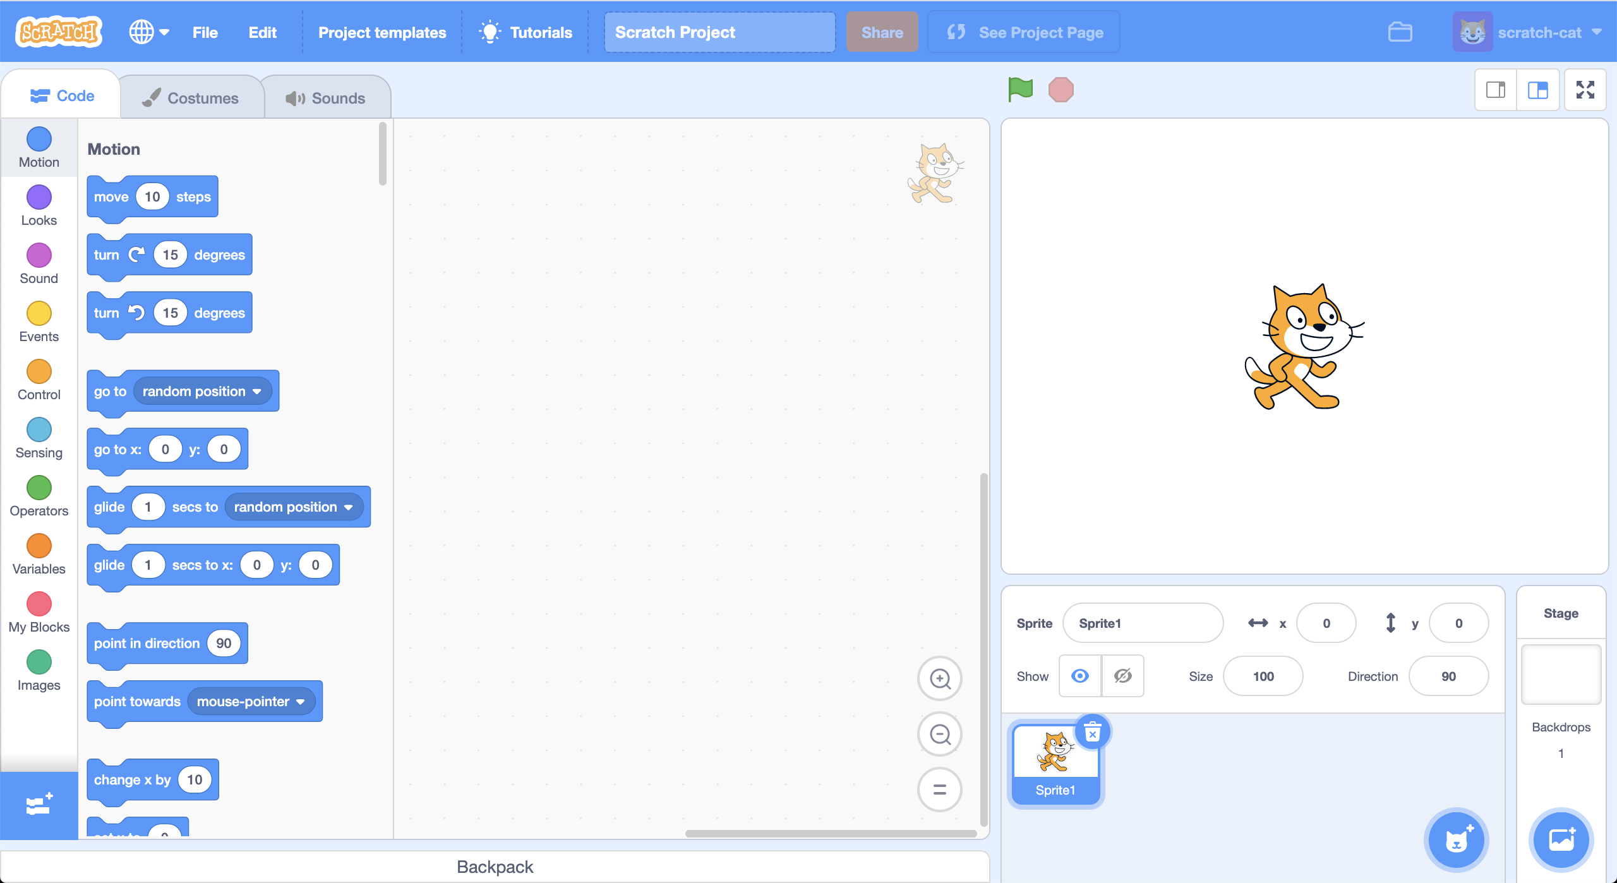
6. Click on the “**Quiz Show**” template  
   *It might take a few seconds to download.*

1. Open the **Extensions** window  
   *Click on the blue button with the plus icon in the bottom left.*A screenshot of a computer

   Description automatically generated with medium confidence
2. Click on the **Wikipedia** extension  
   *You will need this extension to find the Wikipedia pages that the machine learning model will look in to find answers to questions.*
3. Open the **Extensions** window again
4. Click on the **Question Answering** extension  
   *You will need this extension to use the pre-trained machine learning model that finds answers to questions.  
   It might take a few seconds to download.*
5. Create the following code to set the **subject** variable to the name of your Wikipedia page  
   *You should set the variable to exactly match the name of your Wikipedia page from step 2 – including any punctuation marks*  
   Graphical user interface, application

   Description automatically generated
6. Click on the **computer** sprite and find the **answer the question** code  
   *In the template project, the computer is going to pretend to think for 5 seconds and then answer “I don’t know”.  
   This is the code you will need to update!*  
   Graphical user interface, application

   Description automatically generated
7. Update the code so that it looks like this  
   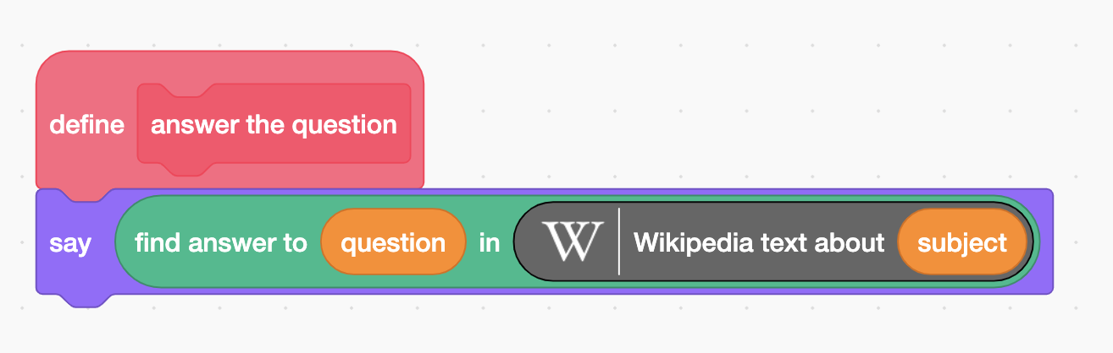

This gets the text contents from a Wikipedia page.  
You can click on it to see what it returns:  
*  
*This gets the text from the Wikipedia page you chose, using the variable you set in Step 11.*  
  
*This is the pretrained machine learning model you will use to look for answers. It will search for the answer to the “question” question, in the “passage” text.*Graphical user interface, text, application, chat or text message
*This will look for the answer to the question in the* ***question*** *variable (which is set by the project template) in the contents of the Wikipedia page you chose using the* ***subject*** *variable.*

1. Think of a quiz question  
   *Look in the Wikipedia page you have open from Step 2. Find a fact on that page that you think would make a good quiz question.  
   For my topic, I decided to use “What colour are the tennis balls?”*
2. It’s time to play!   
   *Try to find someone that can play against the machine learning model.  
   It could be someone in your class, or a family member if you’re doing this at home.*
3. Click on the **Green Flag**.
4. When you see the prompt for the next question, type in the question you thought of in Step 14, and then press **Enter**  
   Graphical user interface

   Description automatically generated
5. Say the question to your human competitor  
   *Wait for both your contestants to come up with an answer.   
   The computer can take a little while – please be patient!*
6. Decide if the answers from your competitors are correct. Click on the tick or cross for each competitor.  
   *Running the game in full-screen makes it easier to avoid accidentally moving sprites when you click on them.*  
   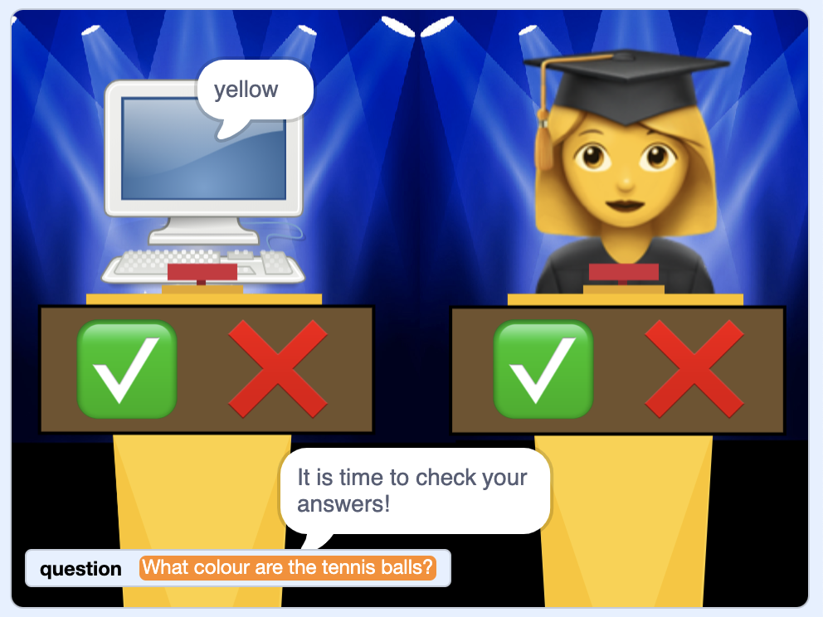
7. Think of another question and try it again  
   *Scores on the podiums will update if you said the answers were correct.*  
   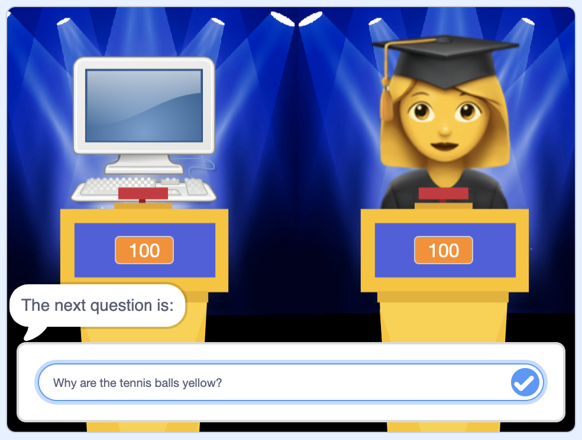
8. Repeat with different types of questions to see what sort of questions your competitors find easier or harder.   
   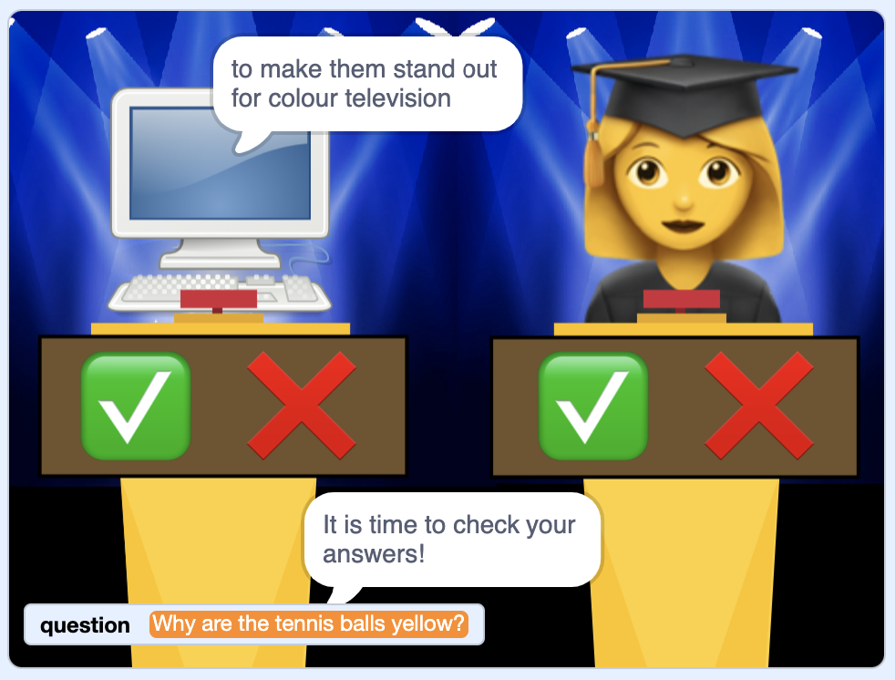
9. Try doing a quiz show round on a different category, by changing the **subject** variable that you set in Step 11.  
   *You need to click on the Green Flag again to get that code to be run.*
10. Who won your quiz?  
    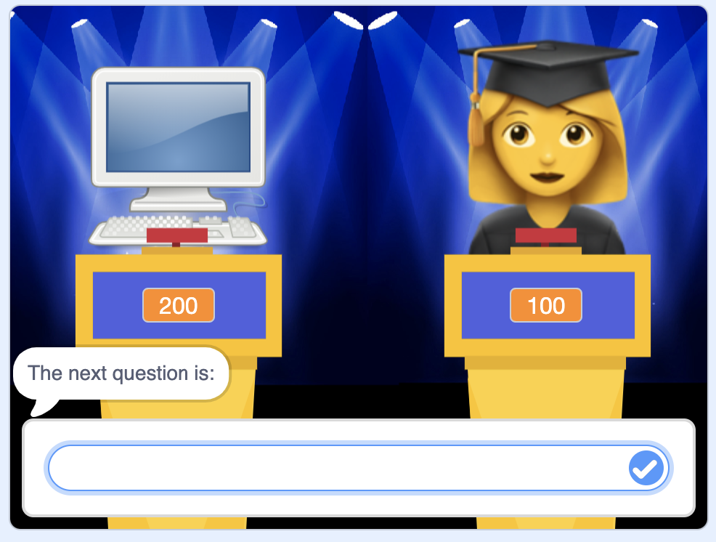

**What have you done?**

You’ve made a Scratch project to demonstrate “Question answering”.

Question answering is where a computer has to sufficiently recognize the meaning of a question to be able to retrieve an answer.

This has been a subset of Machine Learning research for many decades.

For example, in 1961 researchers at Stanford University made “BASEBALL” – a computer that could answer questions about baseball.

<https://ibm.biz/baseball-qa>

These early systems relied on being able to retrieve answers from carefully prepared “knowledgebases” – data that has been organised and structured to make it easier for computers to look up answers in.

In more recent years, researchers have focused on Question Answering systems that can retrieve the answer from a collection of documents (called a “corpus”).

A highlight in the ability to retrieve answers from unstructured documents came in 2011, when IBM made a question answering system called “Watson”. It was demonstrated by being entered into a television quiz show called Jeopardy! where it competed against two of the best human players to have played the game.

<https://ibm.biz/watson-qa>

**How was it trained?**

If you’ve done other Machine Learning for Kids projects, you likely know that training a machine learning model requires training data – examples that the computer can use to learn how to do a task.

For this task, training the model needed training data made up of 100,000+ questions, and the location of the answers to those questions in Wikipedia pages.

If you’d like to see the training data that was used, visit <https://ibm.biz/squad-qa>

**Ideas and Extensions**

Now that you’ve finished, why not give one of these ideas a try?

Or come up with one of your own?

**Use speech recognition so you can ask your questions**

Instead of typing in your quiz questions, you could speak them. Try using the pretrained speech recognition machine learning model to do that.

**Try answering questions on multiple topics**

Try combining the contents of several different Wikipedia pages into a single long passage, and see if the machine learning model can still find the answers to your questions.